**Manual Tagging Process.**

Below is the architecture, once tags changes, it should visible on Power bi Reports.

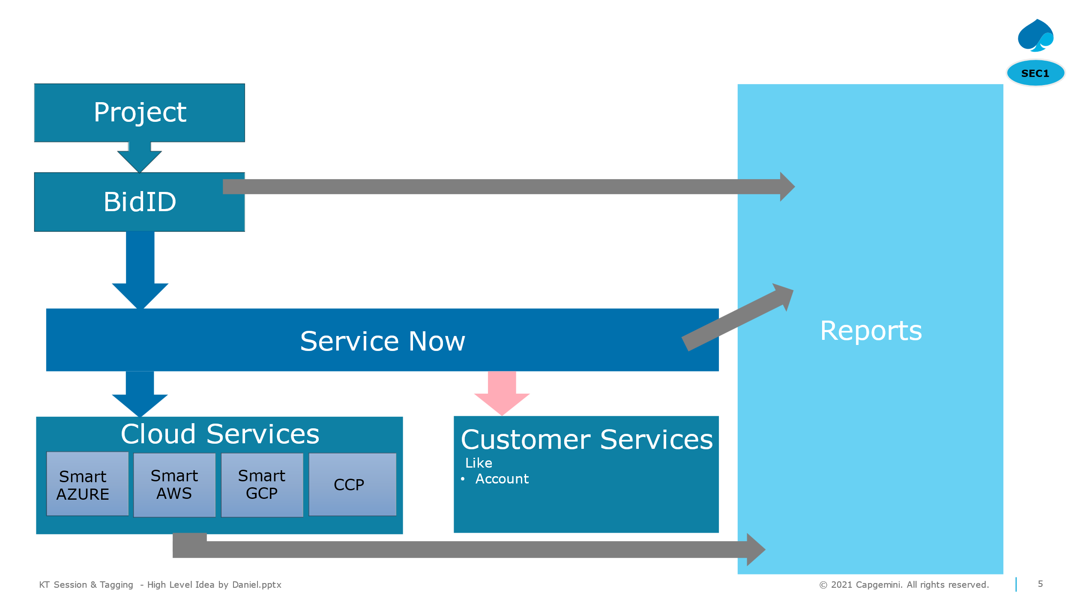

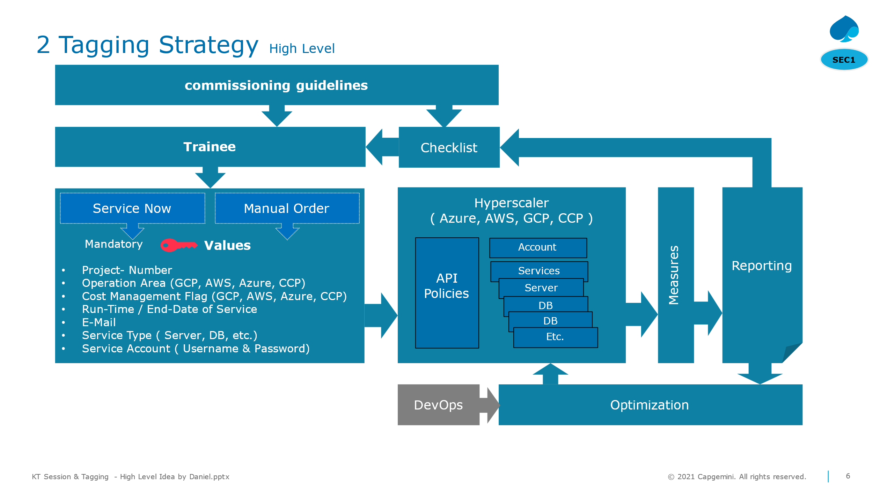

1. **Tagging Process:**
2. **a) Standard Request**

A standard tagging request consists of reassigning current finops tags that are visible on Cloud cost Optimization Tools (Flexera and the Hyperscalers version of the tool e.g: AWS Organizations).

Standard Tag Request consists of finops tags such as

* finops_account-id,
* finops_account-name,
* finops_application-environment,
* finops_division,
* finops_application-id,
* finops_application-name,
* finops_regulatory-relevant

The Standard code can be found on our GitHub – named “ :- Mike_standard_batch.ipynb” python file

In the Script,

1. We start by importing our data from Flexera.
2. Loading the Batch that needs to be tagged.
3. Manipulating the data to be tagged on the hyperscalers.
4. Finally, we have .csv files that are ready to be tagged.

We get different types of CSV files for AWS, GCP and Azure depending upon the accounts from tagging file.

Then on the Bayer Side.

1. For the specific Hyperscalers (AWS Organizations, Azure Portal, GCP Labels),
2. Go to the terminal for the specific hyperscalar
3. There upload the tagging script (available on CG Teams Channel) and upload the intended .csv file.
4. Execute the relevant terminal commands (available on the CG Teams Channel)  
   E.g: for Tag Execution
5. python3 aws_account_tagging.py --source_file Tagging_Update_Request(Wilke)_Monsanto.csv
6. You should receive the result in output.txt and error.txt

Azure code :-

GCP code :-

These code are available in the teams channel of tagging’s.

1. **b) Non-standard requests**
2. **b.1.1) CCP Azure**
3. For Requests in CCP Azure, you have to enter Azure Portal in loggin.
4. In Azure Portal, Under Data Storage -> Containers -> batchtaggingdata, upload your CCP .csv file
5. Use Runbook “azureBatchTaggingV2”, in the parameters enter the .csv file name.
6. In the Output, the Batch Accounts should be shown as tagged.

1. **b.2.1) CosmosDB Accounts**
2. For Tagging the accounts in CosmosDB, we have a .ipynb notebook
3. Upload the .csv file and run the script.

1. **b.2.2) OCI Accounts (Oracle)**
2. The interaction is similar to CosmosBD Tagging.

General

* Semi-automated process to update individual tags based on source files (e.g. Excel) sent to FinOps team by division stakeholders (e.g. AmberLynn Ostertag)

Data Wrangling

* Excel data needs to be cleaned and converted into csv file for execution
* Data types
  + Account id should be a string (and leading zeroes should remain)
  + Beat-id should be verified via ServiceNow API

AWS

* Methodology
  + Usage of SMART AWS' Metadata API

Azure

* Methodology
  + Usage of Azure Automation Runbook
* Prepare source file in csv and upload to Blob
* Storage account: finopsreportingdata
* Container: [batch-tagging-data](https://portal.azure.com/#view/Microsoft_Azure_Storage/ContainerMenuBlade/~/overview/storageAccountId/%2Fsubscriptions%2F0459b689-7a30-4ba7-bce0-56d318762fe7%2FresourceGroups%2Ffinops-data-store-rg%2Fproviders%2FMicrosoft.Storage%2FstorageAccounts%2Ffinopsreportingdata/path/batch-tagging-data/etag/%220x8DBBA82AD36B43D%22/defaultEncryptionScope/%24account-encryption-key/denyEncryptionScopeOverride~/false/defaultId//publicAccessVal/None)
* Content: subscription id + tags that were requested for change
* Structure:
* finops_account-id,finops_application-id
* 46d980aa-f39f-4106-bee6-26d2eaf332c0,beat04043366
* 92655c29-a25b-4f67-9df1-d01827fa6b29,beat04043366
* Execute runbook [azureBatchTaggingV2](https://portal.azure.com/#@bayergroup.onmicrosoft.com/resource/subscriptions/0459b689-7a30-4ba7-bce0-56d318762fe7/resourceGroups/finops-automation-rg/providers/Microsoft.Automation/automationAccounts/finops-azautomation/runbooks/azureBatchTaggingV2/overview)
* Add source file name (as stored in blob) as parameter
* Results are automatically stored in Blob
* 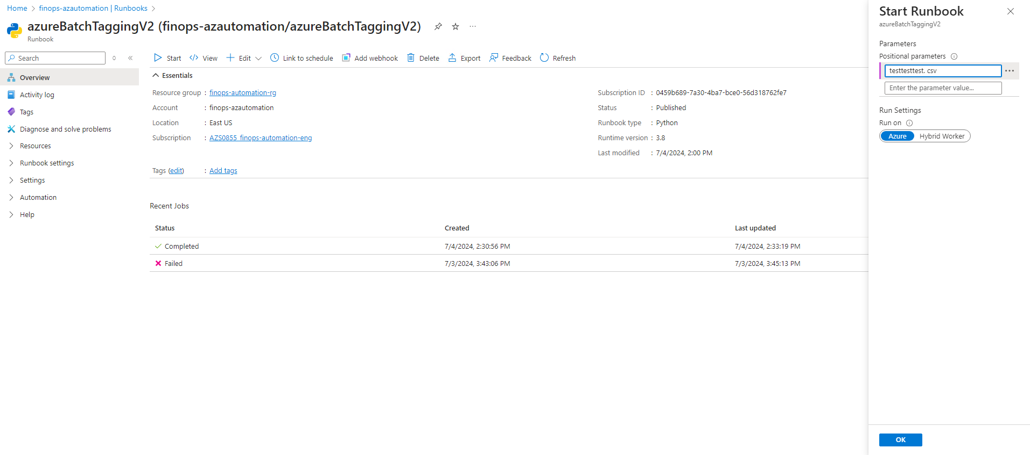

GCP

* Permissions
  + FinOps Tagging role provided by SMART GCP team
* Methodology
  + Execution of Python script in GCP cloud shell
* Login with you primary CWID to the Google Cloud Console
* <https://console.cloud.google.com>

Closed Accounts

* Methodology
  + Make new entry in CosmosDB